**Revolutionizing Marketing Approaches with Viewer Data-Driven Content Automation**

HANISH ROSHAN RAJAN

2433088

*A dissertation submitted to the University of Bristol in accordance with the requirements of the degree of Master of Science in MSc Business Analytics in the Faculty of Social Science and Law.*

**University of Bristol Business School**

September 2024

Word count: 10789

**AUTHOR’S DECLARATION**

I declare that the work in this dissertation was carried out in accordance with the requirements of the University’s Regulations and Code of Practice for Taught Programmes and that it has not been submitted for any other academic award. Except where indicated by specific reference in the text, this work is my own work. Work done in collaboration with, or with the assistance of others, is indicated as such. I have identified all material in this dissertation which is not my own work through appropriate referencing and acknowledgement. Where I have quoted or otherwise incorporated material which is the work of others, I have included the source in the references. Any views expressed in the dissertation, other than referenced material, are those of the author.

I have read and understand the [University’s Academic Integrity Policy](https://www.bristol.ac.uk/media-library/sites/academic-quality/documents/policy/academic-integrity-policy.pdf) including plagiarism, contract cheating, falsifying data and breaching ethical research protocols.

SIGNED: R HANISH ROSHAN DATE:04/09/2024

**ABSTRACT**

This study investigates the effects of targeted advertisements on customer behaviour, with a focus on ad relevance and effectiveness in various buying situations, as well as the influence of product categories and demographics. The motivation of this research comes from the growing importance of digital marketing strategies in current data-driven environment and the main requirement to understand how consumer decisions are influenced by the targeted advertisements. Despite, there are few research gaps in understanding how various factors shape consumer responses. By addressing these gaps this study aims to provide deeper insights into the mechanisms that drive consumer behaviour in the context of targeted marketing The study uses an extensive survey to investigate how recent purchases influence ad perception, the function of consumer dissonance, and brand loyalty. It also looks into how customer responses differ between the fashion and electronics categories, as well as the impact of age and gender on ad effectiveness. The findings provide useful insights for optimizing digital advertising techniques and contribute to a better knowledge of consumer psychology in targeted marketing.

Furthermore, demographic characteristics, notably age and gender, have an important role in defining consumer behaviour. Younger consumers are often more engaged with targeted marketing, particularly in the fashion category, but older consumers are more sensitive to post-purchase ads for gadgets. These findings highlight the need of customizing digital marketing techniques to the unique characteristics of target groups in order to enhance engagement and effectiveness. The implications of this research are important for the marketers who are trying to optimize their advertising strategies by understanding the factors which enhances of devalues the effectiveness. Ultimately, tailoring these factors will improve engagement and conversion rates. In addition to its practical consequences, this study adds to the academic conversation about digital marketing by giving empirical insights into the complicated interplay between consumer behaviour and targeted advertising. It also raises fundamental ethical concerns about consumer privacy in the age of data-driven marketing, advocating for a balanced strategy that values individual autonomy while leveraging personalization for marketing success.

Through a comprehensive analysis of consumer responses to targeted ads, this dissertation offers valuable guidance for marketers seeking to optimize their digital advertising strategies and align them more closely with consumer expectations and preferences.

**TABLE OF CONTENTS**

**ABSTRACT…………………………………………………………………………….2**

**TABLE OF CONTENTS………………………………………………………………3**

**CHAPTER I INTRODUCTION……………………………………………………...5**

* 1. **Research Background…………………………………………………………5**
  2. **Research Significance…………………………………………………………6**
  3. **Relevance and Importance……………………………………………………6**
  4. **Aims, Research Questions, and Objectives…………………………………..7**
  5. **Structure of the Dissertation……………………………………………….....8**

**CHAPTER II LITERATURE REVIEW……………………………………………..9**

**2.1 Theoretical Frameworks and Consumer Behaviour…………………………9**

**2.2 Impact of Purchase Context on Ad Relevance and Effectiveness…………..10**

**2.3 Consumer Dissonance and Brand Loyalty…………………………………...11**

**2.4 Differences Across Product Categories……………………………………....12**

**2.5 The Role of Demographics in Ad Effectiveness……………………………..13**

**2.6 Consumer Privacy Concerns and Ethical Implications……………………..14**

**2.7 The role of data analytics and AI in enhancing targeted advertising ………14**

**CHAPTER III RESEARCH METHODOLOGY…………………………………....16**

**3.1 Research Philosophy…………………………………………………………...16**

**3.2 Research design………………………………………………………………..16**

**3.3 Questionnaire design………………………………………………………….17**

**3.4 Definition of All Metrics ……………………………………………………...18**

**3.5 Data collection…………………………………………………………………20**

**3.6 Data analysis…………………………………………………………………...21**

**3.7 Ethical Considerations …………………………………………………..……22**

**3.8 Data collection and Data preprocessing………………………………………23**

**CHAPTER IV FINDINGS……………………………………………………………25**

* 1. **Descriptive Statistics…………………………………………………...25**
  2. **Research Question Analysis …………………………………………..26**
     1. **Research question 1…………………………………………..26**
     2. **Research question 2…………………………………………..27**
     3. **Research question 3…………………………………………..30**
     4. **Research question 4…………………………………………..32**
     5. **Word cloud……………………………………………………35**

**CHAPTER V DISCUSSIONS………………………………………………….38**

**5.1 Summary of the study…………………………………………….…..38**

**5.2 Theoretical Contribution …………………………………..……...…38**

**5.3 Discussion of Unexpected Outcomes…………………..……….…….39**

**5.4 Practical Implications………………………………………….…...…39**

**5.5 Research Limits and Future Research……………………………….40**

**CHAPTER VI CONCLUSION…………………………………………………41**

**REFERENCES…………………………………………………………………..42**

**APPENDIX I PIS, CONSENT FORM AND QUESTIONNAIRE …………...46**

**APPENDIX II RELAVANT DATASET………………………………………...68**

**APPENDIX III ETHICAL APPROVAL DOCUMENT……………………….68**

**APPENDIX IV PYTHON CODE……………………………………………… 83**

**APPENDIX V SUPERVISOR AGREEMENT FORM……….………………103**

**CHAPTER I INTRODUCTION**

* 1. **Research Background**

In the rapidly developing landscape of digital marketing, the advent of digital technologies has transformed the marketing domain, which leads to a shift from traditional mass marketing to more personalized techniques, data driven approaches. Targeted advertising, supported by sophisticated algorithms and wide amount of consumer data, has become a cornerstone of modern strategies of marketing. This allows businesses to deliver tailored advertisements based on consumer preferences, behaviors and demographic factors, therefore enhancing the relevance and effectiveness of marketing campaigns. However, as these techniques become more prevalent, there are many questions raised about their impact on consumer behavior and brand loyalty. Nowadays consumers are increasingly exposed to personalized ads which reflects their recent online activities, preferences and their past purchases. Even though these advertisements are designed to enhance their engagement, they also have the potential to evoke negative reactions such as cognitive dissonance, privacy concerns and reduced brand loyalty if they are not delivered effectively to the consumers. This research seeks to explore these dynamics by examining how different factors influence consumer perceptions and responses to targeted advertisements.

The study’s relevance is underscored by the growing reliance of businesses on digital marketing strategies and the need for a better understanding of consumer behavior in responses to target the advertising. As businesses increase their investment in programmatic advertising, which automates add buying based on real-time consumer data, it is crucial to understand how these ads are received by the consumers and what all factors support their effectiveness. This study aims to fill these gaps by providing empirical insights into the factors which drive consumer responses to targeted ads and offering recommendations to optimize the digital marketing strategies.

* 1. **Research Significance**

The significance of this dissertation lies in its potential to enhance our understanding of consumer behavior in the context of Target advertising, which is a critical area in the modern digital marketing era. It is explored how these recent purchases, product categories and demographic factors influence the effectiveness and reception of Targeted advertisements, this study gives valuable insights for marketers trying to optimize there are advertising strategies more. Additionally, it also sheds light on consumer dissonance and brand loyalty, offering a deeper understanding of the psychological factors which drives consumers responses. The findings provided in this research could lead to more effective, personalized marketing campaigns that align more closely with consumer preferences, which ultimately contributes to a higher engagement level and conversion rates.

* 1. **Relevance and Importance**

The relevance of the study depends on its potential the inform the design and implementation of more effective digital marketing strategies. As businesses highly rely on data driven approaches to reach consumers day by day, understanding how different factors influence consumer responses to targeted ads becomes critical. The findings of this study could support marketers tailor their strategies more effectively which ensures that advertisements resonate with customers and drive desired outcomes such as increased engagement, conversion rates and brand loyalty.

Furthermore, this study addresses important ethical considerations in digital marketing, which are particularly related to consumer privacy. As personalized advertisements become more sophisticated, the concerns about privacy and the potential for intrusive marketing practices have also risen. By exploring consumer responses to these targeted advertisements, this research also highlights the need for marketers to balance the personalization eventually with respective for consumer privacy, contributing to the ongoing debate of ethical digital marketing practices.

**1.4 Aims, Research Questions, and Objectives**

The primary aim of this research is to explore the intricate relationship between targeted advertisements and consumer behaviour. Specifically, it pursues to understand how various factors such as recent purchase context, product type, and demographic characteristics influence consumer perceptions of ad relevance, effectiveness, and emotional responses, including dissonance and brand loyalty.

The main research questions of this paper are the following four point:

Question 1: What impact does the context of a recent purchase have on the perceived relevance and effectiveness of targeted advertisements?

Question 2: How does the absence of a purchase decision affect consumer dissonance and brand loyalty when exposed to targeted ads?

Question 3: Are there significant differences in consumer responses to targeted advertisements between different product categories (fashion vs. electronics)?

Question 4: Do consumer’s personal traits, such as demographic factors like as age and gender, influence consumer perceptions and responses to targeted advertisements across different scenarios?

the following are the objectives of the dissertation:

1. To assess the impact of recent purchase context on the perceived relevance and effectiveness of targeted advertisements.

2. To examine the influence of the absence of a purchase decision on consumer dissonance and brand loyalty when exposed to targeted advertisements.

3. To identify significant differences in consumer responses to targeted advertisements across different product categories (fashion vs. electronics).

4. To evaluate the influence of demographic factors such as age and gender on consumer perceptions and responses to targeted advertisements across different scenarios.

**1.5 Structure of the Dissertation**

This paper is ordered into five chapters. The first chapter introduces the research topic which outlines the studies objectives, research questions and significance. Chapter 2 presence a comprehensive literature review exploring existing theories and research the related to the perceptions of consumers due to Target advertising. The third chapter describes the research methodology, explaining the design of this study, data collection and data analysis methods. Chapter 4 presents the findings, which offers an in-depth analysis of the data collected. Finally, chapter 5 discusses the implications of the findings providing conclusions and suggestions for possible future research. This structure approach ensures a consistent flow from the research questions to the final conclusions.

**CHAPTER II LITERATURE REVIEW**

This literature review chapter aims to synthesize existing research on consumer perceptions of targeted advertisements. It is organized to first investigate the theoretical frameworks that underpin consumer behaviour in response to targeted ads, then define the impact of purchase on ad relevance and effectiveness. The role of consumer psychology in the effectiveness of targeted advertisements and brand loyalty is then discussed, as well as the differences across product categories, the role of demographics in ad effectiveness, consumer privacy concerns and ethical implications, and finally the role of data analytics and AI in enhancing targeted advertising. In the final section, a concise summary of the literature review is provided.

**2.1 Theoretical Frameworks and Consumer Behaviour**

The concept of targeted advertising, understanding the behaviour of a consumer requires a good theoretical foundation which can explain how consumers process, evaluate and respond to the efforts of personalized marketing. This review draws on several key structures, including cognitive dissonance theory, the elaboration likelihood model (ELM) and the theory of planned behaviour (TPB) to explore these dynamics. *The cognitive dissonance theory*, which explains the uncomfortable sensation that consumers may have when they see targeted marketing for products, they had previously considered but had chosen not to purchase, finds particular significance in this study. Because of this discomfort, customers could try to alleviate the dissonance by changing their behaviour or attitude (Samuel *et al.*, 2021). This theory contributes to the study of how focused advertising may influence or contradict consumer decisions, hence affecting brand loyalty or intent to buy. This is supported by research done by (Shehu, Abou Nabout and Clement, 2021), which shows that the quality of the website hosting the advertisement can either raise or lower this dissonance, particularly when it comes to high-end brands. When it comes to how customers react to varying degrees of product participation, the Elaboration Likelihood Model (ELM) offers insights into how people interpret targeted marketing. This methodology is crucial to the study because it explains why some commercials may be more effective than others, depending on whether consumers are processing information centrally or peripherally. (Shehu, Abou Nabout and Clement, 2021) claim that peripheral cues, such as the perceived quality of the website or the visual attractiveness of the commercial, have a significant influence on consumers' perceptions of companies when their interaction with the company is low.

This research is further supported by the Theory of Planned Behaviour (TPB), which establishes a connection between behavioural intentions and consumer attitudes, subjective standards, and perceived control. This hypothesis helps explain how focused advertising can affect consumers' long-term behaviour in addition to their immediate purchasing decisions. One important factor in evaluating the relevance and efficacy of commercials is their alignment with consumer values and beliefs, as demonstrated by (Dwivedi *et al.*, 2021) commercials that reflect these characteristics are more likely to result in positive behavioural results.

**2.2 Impact of Purchase Context on Ad Relevance and Effectiveness**

The context when a purchase is been made is influenced significantly how consumers perceive and respond to the targeted advertisements (Ciuchita *et al.*, 2023). The effectiveness of ads mostly depends on how relatively they align with the customers recent purchase behaviour, timing and the relevance of the promoted products or services. According to (Uday Kiran and Arumugam, 2021) programmatic advertising has completely changed how marketers target customers by enabling more exact timing and contextually relevant ad placements. The integration of advanced attribution modelling, as discussed by (Diemert *et al.*, 2017), further improves the efficiency of these strategies by enhancing the bidding process based on real-time data and user interactions. using real-time data, this type of advertising shows customers adverts that are more likely to connect with them based on their recent online activity, including previous purchases (Weinlich and Semerádová, 2017). Furthermore, highlighting the fact that customers are more likely to find advertisements relevant and helpful when they come across them quickly after making a linked purchase is research (Ciuchita *et al.*, 2023). By appealing to the consumer's preexisting interests, this immediacy can enhance engagement and raise the likelihood that they will make a purchase. Nevertheless, the ads lose their effectiveness with time, especially if they don't change with the demands of the consumer or keep promoting products that the client has already bought (Frick, Belo and Telang, 2023). Furthermore, (Alaimo and Kallinikos, 2018) study emphasizes how personalized information improves the relevancy of advertisements. Ads that consider the consumer's past purchases and adjust the messaging appropriately are more likely to receive positive feedback from the public. Because of this customisation, the advertisement is seen as more relevant and effective at influencing other behaviours, such repeat business or greater brand loyalty.

However, the demonstration of ad relevance and effectiveness can be further explained by considering consumer psychology, particularly the role of hyper-personalization. This leverages the granular data from ad viewing and other consumer interactions, which lets the marketers create high potential messages. This practice can enhance the connection between the consumer and advertisements, at the same time it also raises concerns about personal data and data security. There is a high chance that consumers might experience heightened anxiety about information authorization, data leakage risks, and the overall protection of their personal information (Pawlata and Cakir, n.d.). These additional perspectives from consumer psychology suggest that these privacy concerns could significantly impact the perceived relevance and effectiveness of ads, if the consumers feel their privacy is at risk regardless of its personalization level. Addressing these concerns transparently and ethically can help mitigate the risks linked with hyper-personalization and maintain effectiveness of targeted advertisements.

**2.3 Consumer Dissonance and Brand Loyalty**

Brand loyalty can be strongly impacted by consumer dissonance, a psychologically uncomfortable situation that arises when customers come across information that contradicts their decisions or beliefs. This relationship is especially clear when it comes to programmatic advertising, where the accuracy of targeting can either make dissonance go away or get worse (Cooper *et al.*, 2023; Núnez-Barriopedro, Cuesta-Valiño and Mansori-Amar, 2023; Palos-Sanchez, Saura and Martin-Velicia, 2019). As (Watts Mack, 2016) explains, targeted advertisements have the potential to cause dissonance, which lowers brand loyalty, when they don't match the consumer's expectations or previous purchasing behaviour. Customers frequently experience this dissonance when reminded of items they choose not to buy, which makes them uncomfortable and makes them second-guess their choice (Högström and Wallin, n.d.). While consumer dissonance is a significant factor, differentiating it from other forms of negative consumer motivation is essential., like dissatisfaction and regret. Where dissatisfaction generally happens when a product or service fails to meet the customers’ expectations leading to a negative evaluation and reduced loyalty, on the other hand regret arises when the purchased product is compared to other alternatives which were not selected. It is a post-decision emotional state leading to lower satisfaction and decreased loyalty. But dissonance can occur before, during or after making the decision process and unlike other negative emotions it is more about the internal conflicts between beliefs and behaviour rather than a direct comparison of choices

In the study by (Chen *et al.*, 2019), the role of artificial intelligence (AI) in programmatic advertising has been highlighted, where it was noted that Artificial intelligence can enhance the relevance of ads, also it has high potential to increase consumer dissonance if the ads are perceived as irrelevant or overly invasive. This increased dissonance might affect brand loyalty negatively, as consumers might begin to view the brand as intrusive or disconnected from their needs.(Sarna, Kozminskiego and Doligalski, n.d.).

**2.4 Differences Across Product Categories**

The effectiveness of the targeted advertisements on the consumers could vary significantly across different product categories, they can be influenced by factors such as consumer involvement, the product nature, and the context of how the products ads are delivered (HARALD J. VAN HEERDE, n.d.). Content recommendation advertising has enabled more precise targeting in recent times, but its effectiveness is not uniform across all the product types. According to (Truong, Nkhoma and Pansuwong, 2020), the impact of mobile in app advertising can differ depending on the product category, with some categories benefiting more from real time bidding and programmatic placements due to their consumer engagement rate is higher. For example, many in-app ads for high involvement products like electronics often yield good results compared to low involvement products, there is more likely that a customer will engage with ads that offer detail information and value proposition that we related to their interests (Prasad, Chokshi and Khan, 2021).

(Wang, Nalluri and Chen, 2023), further emphasize the role of product category in determining the success of programmatic advertising strategies. Their research highlights that product with a higher degree of personalization, such as fashion items, benefit more from targeted advertising efforts. This is because consumers of personalized products tend to seek validation and reinforcement of their choices, making them more responsive to ads that align with their preferences and previous purchases. Finally, (Gonzalvez-Cabañas and Mochón, 2016) research explores how the real-time bidding and programmatic advertising platforms could optimize the ad delivery by selecting the appropriate audience segments depending on the product category. Their findings describe that the efficiency of ad placements enhances when each product category and their unique characteristics are considered which allows for more effective targeting and higher return on investment.

**2.5 The Role of Demographics in Ad Effectiveness**

Determining the effectiveness of targeted advertising depends on crucial demographic factors such as age, gender etc. Understanding these demographic differences allows the marketers to tailor their ad strategies more effectively, which leads to higher conversion rates and higher engagement (Tiet, 2020). (Meirezaldi, 2023) emphasizes that the efficacy of the targeted advertising is highly influenced by demographic factors, particularly age and gender. Younger audiences for example, can engage more with mobile advertisements and digital advertisements, whereas older demographics may respond better to more traditional forms of digital marketing such as emails and banners. (Truong, Nkhoma and Pansuwong, 2020) explores how gender influences add receptiveness, noting that women are generally more responsive to ads that emphasize emotional appeals and brand narrative. In contrast, men tend to respond better to the advertisements which are most focused on product features and practical benefits. This gender difference is particularly pronounced in product categories like fashion and electronics, where the approach to advertising needs to be tuned finally to the target audiences according to their preferences (Deng *et al.*, 2019). Moreover, (Pan *et al.*, 20AD) discuss how the income level affects the ad effectiveness also. Higher income consumers are more likely to respond to premium brands and luxury products, often favouring ads that highlight exclusivity and quality. However, lower income consumers might be responsible to discounts, value-oriented messaging and promotions. This income-based segmentation is crucial for advertisers which aims to maximize the impact of their campaigns across different consumer segments.

**2.6 Consumer Privacy Concerns and Ethical Implications**

The use of targeted advertising continues to grow eventually so do the concerns about consumer privacy and the ethical implications of data driven marketing practices (Wang, Xiong and Yang, 2019). The general data protection regulation (GDPR) has significantly impacted how the companies can collect, store and use consumer data leading to a more cautious approach in targeting advertising(Nordman, n.d.) (Dahl and Ericsson, n.d.). According to (Pawlata and Cakir, n.d.), the introduction of the transparency concerned framework (TCF) has been a crucial step to ensure that the programmatic advertising complies with GDPR requirements (Lee1, n.d.). The users can control their data by providing consent for its use by TCF, but it has also highlighted those challenges of maintaining ad effectiveness while respecting user privacy (Niininen, n.d.). Without proper user privacy consent, the effectiveness of targeting, retargeting and cross device tracking is severely diminished which leads to a potential decrease in overall campaign performance (Andrew, 2019; Balocco and Li, n.d.; Nalluri *et al.*, n.d.). explored the evolution of audience economics and how targeted advertising has transformed the commoditization of audiences. A transition from larger homogeneous audiences to individualized data profiles has raised ethical conscience about the extent to which consumer behaviour is tracked and analysed (Ahmad, Teimouri Mokarram Tutor and Kumeto, 2015). This shift has brought to light the tension between the need for personalized advertising and the right to privacy, with critics arguing that the latter is often compromised in Favor of the former.(Rodgers and Nguyen, 2022; Omodolapo Bakare and Tolulope, 2021; Bolkvadze, Ekblad and Borg, n.d.).

**2.7 The role of data analytics and AI in enhancing targeted advertising**

The integration of data analytics and artificial intelligence (AI) into targeted advertising has revolutionized the way advertises reach and engage with audience. This transformation is extremely due to the advanced capabilities of AI and data analytics offer in terms of understanding the behaviour of the consumer, predicting future actions, and optimising ad delivery in real time (Kumawat and Vajpai, 2022; Luiss, Carli and Kallinikos, 2017). Targeted advertising, which relies heavily on AI driven data analytics, allowing advertisers to automate the buying process of ads, by targeting specific audiences with precision and efficiency (White and Samuel, 2019). This automation is achieved through real-time bidding process where AI algorithms analyse large amounts of data to determine the optimal ad placement (Niklas Karlsson, 2022). The feedback control mechanism within these AI systems is used to ensure that the ads are not only reached to the right audience but also align with the advertisers’ goals and the preferences of consumers (Niklas Karlsson, 2022; Antunes, 2020). Furthermore, based on user data AI driven analytics enables the personalization of add content, which enhances the relevance and effectiveness of the ads (Ai Le Yli-Kuivila, n.d.). As noted by (Niklas Karlsson, 2022), the ability to tailor ads to individual use of preferences is based on historical data and real time behaviour, significantly increases engagement rates and improve the return on investment for advertisers. This personalization is further supported by advanced mission learning techniques that predict user behaviour allowing for more strategic a placement and the continuous optimization of advertising campaigns (Araujo *et al.*, 2020; Klee, n.d.).

**Conclusion**

In spite of doing extensive research on evaluating consumer perceptions, there still remains a significant gap in understanding how specific factors such as product categories, demographic factors etc. are responsible for influencing consumer behaviour. Therefore, these gaps highlight the requirement for this comprehensive research model which addresses these complications of these variables on ad effectiveness and the perceptions of the consumers. This literature review has synthesized key findings from the existing research on consumer responses to targeted advertisements, highlighting the importance of factors such as purchase context, product categories, demographic influences, and privacy concerns. The review underscores the need for marketers to adopt a nuanced approach to digital advertising, one that considers the unique characteristics of their target audience and the ethical implications of their strategies. By building on the insights provided by the literature, this study aims to contribute to the ongoing dialogue on how to optimize targeted advertising practices in a way that benefits both consumers and marketers.

**CHAPTER III RESEARCH METHODOLOGY**

**3.1 Research Philosophy**

In this paper, this study rooted for positivism, which emphasizes the importance of objective and observable phenomena in understanding consumer behaviour. The aim is to objectively measure how different factors such as context of recent purchase, product categories and demographic characteristics affect consumer behaviour and responses to target the advertisements. Furthermore, offering insights that are both empirically grounded and theoretically informed. This approach not only strengthens the validity of these research findings but also does a contribution to the broader understanding of digital marketing strategies in influencing decision of consumers.

**3.2 Research design**

A quantitative survey methodology was used as the research design for this study due to its capacity to evaluate and collect data on consumer perceptions and responses to targeted advertisements in a systematic manner. The goal of this research, which are to find the patterns associated among a sizeable sample of participants in order to offer generalizable insights into consumer behaviour, are especially well suited to the quantitative study method. The primary reason for choosing a quantitative approach lies in the capacity to quantify the consumer attitudes received as well as the behaviours in a way that it is both comparable as well as measurable. By publishing a structured questionnaire with standardized questions, this approach enables the collection of numerical data which can be subjected to rigorous statistical analysis. This is essential for answering the research questions, which mainly Focuses on measuring the impact of various different variables, such as product categories, demographic factors, context of recent purchase, on consumer perceptions and emotional responses to targeted advertisements. Key metrics in the study, such as relevance, efficacy, dissonance, and brand loyalty can be analysed more easily with the use of the quantitative approach. For instance, the use of Likert scale questions illustrates how to precisely measure this variable, clearly providing how various scenarios and evens impact customer behaviour. Furthermore, the quantitative aspect of the survey guarantees statistically that the findings are robust, enhancing the reliability and validity of the conclusions drawn from the data.

A survey method was approached for this research as the most appropriate tool for this because it allows for the efficient collection of data from diverse and large samples of participants. Surveys particularly give advantage in research that seeks to collect an individual attitude, opinion, and behaviours data across different contexts. In the study, the survey was designed to capture responses to various advertising scenarios, each reflecting different consumer experience using different products in an online shopping. Moreover, the survey method supports the use of cross-sectional design which enables the collection of data at a single point in time from a large sample. This is very crucial for understanding the current consumer attitudes and how they might vary across different demographic groups. The standardized nature of the survey ensures the consistency in response, which is highly critical for examining a reliable statistical comparison and conclusions.

**3.3 Questionnaire design**

The usage of questionnaire in this research was a strategic choice, where it systematically collects data on both perceptions of consumer and the responses to targeted advertisements across different scenarios. A questionnaire allows you to gather efficient standardized data from a large number of people, which facilitates the analysis of patterns and trends within the targeted population. The questionnaire was designed to capture a comprehensive range of consumer reactions to various scenarios of seeing advertisements. Every scenario was carefully crafted to reflect a realistic online experience, involving different products and varying contexts. This design flow and showed that the responses would delve valuable insights into how the consumers perceive ad relevance, effective, dissonance, and brand loyalty in relation to their recent shopping behaviour.

In this study, there are 4 scenarios which has 2 products in 2 different situations. Where this allows the participants to differentiate their emotions for certain product at certain times. All the scenarios had the same questions to have a comparison between different scenarios answers provided by the participants.

***Scenario 1 (Headphones - Did Not Buy)****:* Participants were asked to imagine browsing for headphones online without making a purchase and then encountering related ads across various platforms.

***Scenario 2 (Fashion Clothing - Bought)****:* After buying a fashion item, participants envisioned seeing advertisements for related products on several channels.

***Scenario 3 (Fashion Clothing - Did Not Buy)****:* Participants imagined looking through clothing articles online, not buying anything, and then seeing targeted advertisements for related goods later on.

***Scenario 4 (Headphones - Bought)****:* Participants were asked to imagine purchasing headphones and then receiving ads for related products across multiple digital platforms.

Every question in the survey was structured using a Likert scale which allows the participants of the survey to express their intensity of their agreement as well as disagreement with specific statements. This approach was chosen because it allows to quantify the attitudes and perception, making it easier to assess statistical analysis on the collected data. The questionnaire also included a series of demographic questions to enable the segmentation of data based on different age categories, genders. This part was highly essential for studying the potential influence of demographic characteristics on consumer behaviour which is one of the key objectives of the study.

**3.4 Definition of All Metrics**

To examine consumer views and responses to targeted adverts, several critical variables were created and measured in this study using a survey. These measurements are critical for analysing the success of advertisements in various scenarios, as well as the emotional and behavioural responses of participants (Uday Kiran and Arumugam, 2021; Alaimo and Kallinikos, 2018). Each indicator was operationalized using specific survey questions, allowing for a quantitative examination of various elements of consumer behaviour.

***Relevance*** refers to the extent to which the advertisements that are targeted are perceived as applicable or pertinent to the customers’ needs or their interests. In the study relevance was measured by asking participants of how relevant they found the ads for products they had recently viewed or purchased (Uday Kiran and Arumugam, 2021).

Survey Question: How relevant did you find the ads for products you have recently viewed (or bought)?

The degree of which targeted advertisements influence customer behaviour is being captured by the ***effectiveness***, specifically in terms of prompting further engagement, which makes considerations of additional purchases or influencing a decision to revisit a product (Frick, Belo and Telang, 2023; Shehu, Abou Nabout and Clement, 2021).

Survey Question: Have these cross-platform ads ever influenced your decision to go back and make a purchase?

***Dissonance*** refers to the regret or discomfort feel created in a customer after seeing the targeted advertisements, especially when the ads contradict their prior decisions or perceptions. This metric analyses the emotional distress or tension experienced by the participants in response to seeing these ads.

Survey Question: Did you encounter any dissonance after seeing the personalized ad?

***Brand loyalty*** assesses the degree to which targeted commercials strengthen a consumer's allegiance or commitment to a brand. This indicator assesses if the advertisements strengthen the consumer's relationship with the brand, increasing the likelihood that they will continue to buy from or support the company(Antunes, 2020).

Survey Question: Have these ads increased your loyalty to the platform or brand?

When a targeted advertisements make a consumer think about purchasing additional products from the same brand it reflects the likelihood of ***purchase consideration*** metric. This metric captures the advertisements’ ability to trigger an interest in customers for further purchases beyond the initial or considered product.

Survey Question: Have these ads made you consider purchasing additional products from the same brand?

***Frequency of ad noticing,*** this metric assesses how often participants notice the ads for products they have previously viewed on different platforms. It measures the visibility and recall of targeted advertisements across different digital environments.

Survey Question: How often do you notice ads for products you’ve previously viewed on other platforms?

**Privacy concern** captures the level of discomfort or worry feel created in participants about their browsing data being used to show ads on various different platforms. This metric is used to extent to which targeted advertisements raise concerns about data privacy and security.(Palos-Sanchez, Saura and Martin-Velicia, 2019; White and Samuel, 2019)

Survey Question: How concerned are you about your browsing data being used to show you ads on different platforms?

***Overall satisfaction***, the participant's overall satisfaction level indicates how happy or unhappy they are with viewing advertisements for goods they have expressed interest in on various platforms. It captures the overall impression of ad exposure in terms of satisfaction or displeasure.

Survey Question: Overall, how satisfied are you with seeing ads for products you've shown interest in on other platforms?

Furthermore, there were few posts survey questions that could help capture the overall satisfaction or dissatisfaction feel after taking the survey, and open-ended question it's been asked to assess the sentiment of the participants accurately to the scenarios they have faced. Each of these metrics were carefully selected to capture different dimensions of customers experience with targeted advertisements. By measuring these metrics quantitatively through the survey, this research aims to give a comprehensive understanding of how these targeted advertisements create influence on customer behaviour and perceptions across various scenarios. These insights are critical for developing more effective and consumer friendly digital marketing strategies by increasing more personalized ads for selected audience.

**3.5 Data collection**

There are two types of shopping experience faced by the audience, offline shopping and online shopping, where some of the customers might go solely for offline shopping and might have different opinions on this research, hence this study indicates that it is exclusively for the customers who do shopping online. Where they can experience the targeted advertisements. The main key theme of this project is to investigate about consumers reactions to the targeted advertisements and their concerns. So, the survey was created in an online administered tool “*Qualtrics*” and was distributed across many online platforms and social media platforms to solely get participants who are active online. A total of 130 participants were expected to be sufficient to collect data but after data cleaning and removing some fault entries a total 104 valid participants were recorded.

**3.6 Data analysis**

In this research, the primary usage of qualitative methods helped analyse measurable data, offering statistical insights into patterns and relationship among variables. Moreover, the qualitative methods focus on understanding the sentiments and perceptions of the participants, which adds depth to the numerical findings.

***Descriptive Statistics (Quantitative Analysis)***

Metrics such as mean, median and standard deviation were calculated for each survey question across every scenario. Descriptive statistics were the foundational steps in this data analysis process. These statistics provided a summary of Central tendencies and variability within the data, which offers an understanding of how the participants responded to the targeted advertisements in different contexts. Therefore, these statistics were crucial for identifying general patterns and differences in perceptions of the consumer, which also set the stage for more in-depth analysis.

***Correlation Analysis (Quantitative Analysis)***

Correlation analysis was conducted to understand the relationship between different variables. This technique was used to investigate how various factors such as ad relevance and brand loyalty, were related to each other across different scenarios. Correlation analysis was extremely useful for identifying the higher relevance scores which were associated with increased brand loyalty or reduced dissonance, hence offering a deeper insight into these interconnectedness of consumer responses to the targeted advertisements.

***Comparative Analysis (Quantitative Analysis)***

The exploration of differences in consumer responses across various scenarios and demographic groups were assessed with comparative analysis. This technique involved comparing key metrics such as relevance, effectiveness, dissonance etc between different product categories and also between different scenarios where participants either made a purchase or did not make a purchase. Comparative analysis helped to highlight significant variations in consumer behaviour, providing insights into how various context and different products could influence perceptions of targeted advertisements.

***Visualization Techniques (Qualitative Analysis)***

Data visualization played a huge role in the study, where it helped to make complex data more accessible and easier to interpret. Various tools like bar charts, box plots and word clouds were utilized to present these findings clearly and effectively. Bar charts and box plots that particularly useful for demonstrating the differences in responses across scenarios and demographic groups. While word clouds were utilized to visually represent the key themes and sentiments expressed in the post survey responses.

***Word Cloud (Qualitative Analysis)***

To broader the understanding of participants emotions and sentiments were also crucial as it highlights the central theme of both positive and negative sentiments created by the targeted advertisements. A word cloud analysis was conducted on the open-ended responses from the Post survey question, where participants provided qualitative feedback on their overall experience with the targeted advertisements. This technique involved generating visual representations of most frequently mentioned words, capturing the emotional and subject to aspects of consuming experiences that are not easily quantifiable.

**3.7 Ethical Considerations**

Prior to participation in the survey, a participation information sheet and a consent form were provided where the participants will have the chance to review all the information regarding the survey questions and select whether or not to complete them. Furthermore, participants have the right to withdraw from the study at any point and any relevant data will be instantly erased from the research. Finally, to protect participants privacy, the questionnaire will expressly mention at the outset that the entire process is anonymized, and no identities will be required in this questionnaire.

**3.8 Data collection and Data preprocessing**

***Sampling Approach***

In this research, the data for this study was collected by an online survey administered software called Qualtrics. The survey which was conducted was designed to make sure there is an understanding of perceptions of the consumer and the response behavior to targeted content advertisements across different platforms in different scenarios. The survey was created and was distributed on 5th July 2024, once the Ethics approval was granted. The data collection period concluded on August 15, 2024, a total of 41 days. The survey Included 4 scenarios having eight questions each. A total of 104 surveys were collected during this time frame for each scenario. The data, which was collected in the set of 104 questionnaires, there were 76 male, 28 females and 0 in others category. Whereas age distribution between the participants has the highest in the 18-24 categories with 33 participants, 25-34 category has 22 participants, 55 and above category has 19 participants, 45-54 age group category has 16 participants, 35-44 age group category had 10 participants and finally participants age below 18 consists of just 4 people.

***Structure of Questionnaire***

Every single participant in the survey had the same scenarios and same questions to be answered as there were a pair of two product categories in two situations each. In *scenario 1* the participants are required to imagine browsing an online electronic store for headphones, adding items to their Wishlist but not making a purchase. Over the next few days, they are observing some targeted ads for similar products. In *scenario 2,* The product the participants are purchasing is a designer jacket bought online where eventually platforms still show targeted ads for related fashion items across different platforms for the consumer even after making the purchase. In scenario 3 which is quite like scenario 1 as the context of the browsing the product without making a purchase remains same, but the product in this scenario is a designer jacket same as in scenario 2, followed by targeted ads trying to entice them back to buy. Finally in the scenario 4 participants imagined buying a pair of headphones and still later receives content advertisements for complementary products like headphone cases and premium music subscription etc. Also, there are 5 post-survey questions at the end of the survey to ensure the quality and reliability of the collected data and satisfaction of participants. Every question from each scenario was followed by a series of Likert scale assessing various aspects of the participants experience which includes the relevance of the advertisement, dissonance, influence on purchasing decisions, brand loyalty and privacy concerns.

***Data Collection Operation***

A total of 130 participants were initially targeted as an average of 40 participants per scenario. But after the data cleaning process the final sample consist of 104 participants in the survey. The respondents represented a diverse demographic, with different age groups and gender distribution providing a comprehensive data set for analysis.

Once the data collection process was finished, the raw data was exported as a CSV file from Qualtrics which underwent several pre-processing steps to ensure the accuracy and reliability of the data collected. Initially the dataset included many needless columns such as scenario descriptions that did not contain participant responses, columns containing response ID, survey duration, start date, end date, user language etc. These columns were removed to restructure the dataset. There are significant missing data which was identified in the rows and removed. Further manual inspection revealed a few rows with empty cells which were also deleted to ensure a clean dataset. For the remaining data, any missing values within the Likert scale responses are also removed to maintain a clean data set for future analysis. Then to facilitate the scenario comparison during the analysis, we organized the datasets so that the corresponding questions from different scenarios that placed adjacent to each other. For example, the responses to the question about ad relevance in scenario one is placed next to the responses for the same question in scenario 2 this allowed for direct comparison of responses across scenarios. Therefore, the final dataset which was cleaned and reorganized consisted of 104 valid responses, with complete data for all the key questions. This data set was then used for descriptive analysis and further statistical test to address the research questions.

**CHAPTER IV FINDINGS**

**4.1 Descriptive Statistics**

*Table 1: Descriptive Statistics of all 4 scenarios*

|  |  |  |  |
| --- | --- | --- | --- |
| Scenarios | Mean | Median | Standard Deviation |
| SCENARIO 1 | 2.969952 | 3.00 | 1.114676 |
| SCENARIO 2 | 2.846154 | 2.88 | 1.109240 |
| SCENARIO 3 | 2.850962 | 2.88 | 1.141199 |
| SCENARIO 4 | 2.765110 | 2.714286 | 1.205664 |

The descriptive statistical analysis helps to understand the central tendency and variability of key numeric features of all the respective scenarios faced by the participants followed by their responses. In *scenario 1* participants generally perceived the ads as more relevant than other scenarios as this scenario had the highest mean score of 2.96 and a median of 3.00 and a standard deviation of 1.12 which suggests that participants gave a consistent response across the scenario where the product is not bought but still the advertisements are still received. Whereas the content recommendation advertisements were perceived with the neutral to slightly positive reaction in scenario 2 as the mean score for this scenario was 2.84, though they are slightly less consistently than scenario 1 as the median score is 2.88 and the standard deviation of 1.11. In scenario 3 the mean score is 2.84, which is like scenario 2, also there were similar median and standard deviation values compare with scenario 2, which suggest that there’s a consistent perception of ads across scenarios where purchase has been made and not made in the case of clothing (fashion jacket). Finally, scenario 4 has the lowest means score of 2.75 with a median of 2.71 and the highest standard deviation of 1.20 which highly indicates that there is more variation in the responses of the participants in this scenario particularly and generally less favorable perception of ads following a purchase. In contrast, the participants response shows that the scenario which was perceived most favorably are when there was no purchase made. The post purchase ads in the last scenario which was perceived less favorably with greater variability shows the least relevance seen among the participants when the purchase was made with the headphones.

**4.2 Research question analysis**

**4.2.1 Research question 1: What impact does the context of a recent purchase have on the** **perceived relevance and effectiveness of targeted advertisements?**

The relationship between the perceived relevance and effectiveness of targeted advertisement content explored by how the context of a recent purchase will affect them. The data is collected across all the scenarios, each representing a different consumer experience with online purchase and subsequent exposure to targeted ads. The first question asked in every scenario directly asks the participants about the perceived relevance and the third question across every scenario assesses the effectiveness of the advertisements.

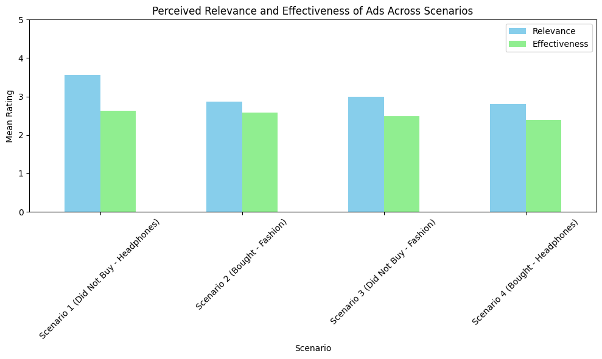

*Figure 1: perceived relevance and effectiveness of ads*

The participants found the ads relevant in every scenario, but the perceived relevance of ads was generally higher in scenarios where participants had not bought the product. specifically, scenario 1 shows the highest relevance rating, followed by scenario 3. In contrast this suggests that the context of having already made a purchase might reduce the apparent need or the interest shown in the advertised products. While the effectiveness of the ads, which is measured by the likelihood of considering additional purchases or having engagement with the brand further, was consistently lower across all the scenarios compared to relevance. However, there was a slightly noticeable pattern where the effectiveness ratings are closer to relevance in the scenarios where the product has been bought by the consumers (scenario 2 and scenario 4). Whereas interestingly, scenario 2 and scenario 4 shows that even though the relevance among the participants was slightly lower, the effectiveness did not drop as much sharply. This demonstrates that even if the participants did not find the ads relevant after the purchase, they still consider them sufficiently influential or much engaging to them. This is possibly due to the fulfillment of the immediate need for the product has been done in scenario 2 and scenario 4, even though the effectiveness of these ads remains relatively stable. The nuanced impact that the context of a recent purchase has on the targeted advertising it's been highlighted here. While relevance may decline post purchase, the effectiveness of these advertisements remains significant, which suggests that the advertisers can possibly leverage post purchase advertising to maintain engagement of consumers. Conversely, targeting consumers who have not yet made a purchase might result in higher percept relevance which potentially increases the chances of conversion.

**4.2.2 Research question 2: How does the absence of a purchase decision affect consumer dissonance and brand loyalty when exposed to targeted ads?**

The viewers satisfaction and brand loyalty are the two most important things for a business company to stay in a good position in the market. The absence of a purchase decision highly influences customers dissonance and brand loyalty when they are exposed to targeted advertisements.

*Table 2: Consumer dissonance and brand loyalty statistics*

|  |  |  |  |
| --- | --- | --- | --- |
| **Consumer Dissonance Statistics:** | **Mean** | **Median** | **Standard Deviation** |
| Scenario 1 | 3.02 | 3.0 | 1.02 |
| Scenario 2 | 2.84 | 3.0 | 0.93 |
| Scenario 3 | 2.99 | 3.0 | 1.13 |
| Scenario 4 | 2.91 | 3.0 | 1.17 |
| **Brand Loyalty Statistics:** | **Mean** | **Median** | **Standard Deviation** |
| Scenario 1 | 2.34 | 2.0 | 1.11 |
| Scenario 2 | 2.40 | 2.0 | 1.20 |
| Scenario 3 | 2.26 | 2.0 | 1.10 |
| Scenario 4 | 2.43 | 2.0 | 1.28 |

The consumer dissonance across the four scenarios reveals interesting trend where the scenario 1 recorded the highest mean dissonance score of 3.02 with a relatively low standard deviation of 1.02 which indicates that the consistent feeling of dissonance was observed among the participants who did not complete the purchase. This demonstrates that targeted ads which are shown after a decision not to purchase might create discomfort or a sense of regret which leads to a higher dissonance. Similarly in scenario 3 also a high mean dissonance scores were observed relatively of 2.99 with the slightly higher standard deviation of 1.13 which indicates there are more variability in the responses. This reinforces the idea for not making a purchase can led to increased cognitive dissonance, as customers are repeatedly reminded of a decision they already opted against. Meanwhile scenario 2 and scenario 4 where the participants have purchased the product showed lower mean dissonance scores of 2.84 and 2.91 respectively. The lower dissonance observed in these scenarios suggests that completing a purchase decreases the likelihood of experiencing regret or discomfort when the consumers are encountered with related advertisements.

*Figure 2: consumer dissonance and brand loyalty*

Whereas, looking into the impact created by the absence of a purchase decision on brand loyalty is completely different. Scenario one and scenario 3 both recorded the lowest mean brand loyalty scores of 2.34 and 2.26 respectively which suggest that failing to make a purchase does not strongly incentivize consumers to develop loyalty towards the brand. The lower loyalty ratings may indicate that the ads shown post purchase are more effective in fostering a sense of brand commitment. In scenario 2 there was mean brand loyal score of 2.40 which also is slightly higher than the scenario 1 and scenario 3, still explains that the impact of purchase decision on loyalty is not overwhelmingly strong, but significant enough to note. Coming to the final scenario 4 which had the highest brand loyal discover of 2.43 with a standard deviation of 1.28 indicates that post purchase ads have a slightly stronger effect on reinforcing brand loyalty compared to the scenarios with no purchase.

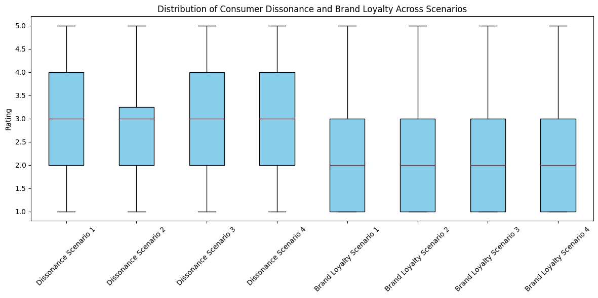

*Figure 3: distribution of consumer dissonance and brand loyalty*

The box plots reveal that that dissonance had a wider range in scenario one and scenario 3 particularly which indicates a more maintained feelings of discomfort among some participants. whereas on the other hand brand loyalty shows less variability, with the median rating consistently around 2.0 across every scenario. However, the slightly higher mean in post purchase scenarios suggests that these advertisements may indeed contribute strengthening consumer loyalty but in general it does not affect the brand loyalty significantly. But for fostering long-term brand engagement the advertisements shown post-purchase seems to have somewhat better impact and might be a more effective strategy.

**4.2.3 Research question 3: Are there significant differences in consumer responses to targeted advertisements between different product categories (fashion vs. electronics)?**

A factor that needs to be considered among the impact in consumer responses is the product categories where there is a high chance of having significant differences in consumer responses to targeted advertisements across different product categories, specifically in case of clothing fashion and electronics. Also, the number of participants is divided into unequal number where male count is 73% and female count is 27% which could lead to a single perspective outcome. To find the difference between the effect of different products, there are two different types of scenarios for both the product categories which needs to be assessed on how the type of product *influences perceptions of ad relevance, effectiveness, dissonance and brand loyalty.*

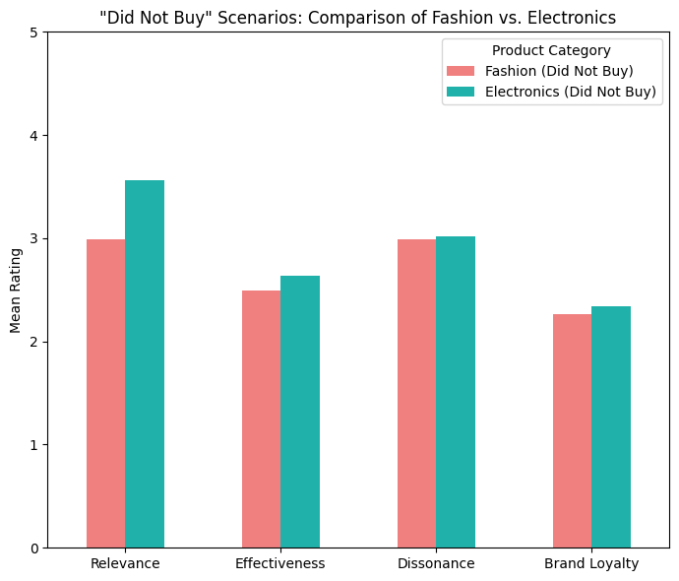

*Figure 4: not bought comparison among fashion and electronics*

ads for headphones were perceived as more relevant than those for fashion items, with mean ratings higher than the main ratings of fashion, In the case of “did not buy” scenarios this suggests that even when a purchase is not made, consumers still find the ads for electronic products more aligned with their interests than compared to fashion related ads. But when it comes to the scenarios where that has been a purchase, the relevance of targeted ads was slightly higher for fashion items (2.88) compared to electronics (2.81). This slight difference indicates that after making a purchase the ads which are shown for fashion items are perceived more directly connected to the recent purchase, which potentially because fashion related products often involved complimentary or coordinated items.

*Figure 5: bought comparison among fashion and electronics*

When it comes to the effectiveness of ads, in terms of influencing the participants to make the purchase or engaging for the with the brand, was slightly higher for electronics than fashion items. Even though the difference is not vast, it demonstrates that electronic product ads are more likely to prompt consumer action, even if the purchase has not been made initially. But the effectiveness of ads post purchase was interestingly higher for fashion products than the electronics. This indicates that fashion ads are most successful in prompting additional purchases or having an engagement after an initial transaction, which could be perhaps due to the nature of fashion products as a category that encourages the consumers for repeated purchases.

Where is the case of consumer dissonance, feeling of regret for having a discomfort after seeing the ads was relatively similar across both categories in the case of “did not buy” scenarios. Interestingly, the consumer dissonance was quite higher for electronics (2.91) compared to fashion products (2.84) in the bought scenarios. Which reflects a greater sense of buyer's remorse or uncertainty following an electronic product purchase, were consumers might question the necessity or value of their purchase more than in the case of fashion products. In terms of brand loyalty, the difference between fashion and electronics products minimal, this suggest that while making a purchase or not making a purchase does not strongly influence brand loyalty in either category, but electronics may still have a marginal advantage in retaining consumer interest.

This analysis reveals the product category thus indeed influence how consumers perceive and respond to targeted advertisements. Electronics products trend to generate higher relevance and effectiveness ratings in non-purchase scenarios, which is possibly due to functional, and necessity driven nature. However, in both purchase scenarios, fashion product ads are slightly more effective and relevant which is slightly due to the complementary nature of fashion products. Despite the differences the overall impact on the brand loyalty reminds similar across both categories which indicates that the targeted ads are equally capable of fostering loyalty regardless of the product types.

**4.2.4 Research question 4: Do consumer’s personal traits, such as demographic factors like as age and gender, influence consumer perceptions and responses to targeted advertisements across different scenarios?**

The response given by the participants could highly vary due to common factors such as age and demographic factors. Particularly age, influence consumer perceptions and responses to targeted advertisements across every scenario. In scenario 1, the relevance of ads was highly rated by the 25-34 and 45-54 age groups, implying that these age groups found the ads more relatable even without making a purchase. Younger participants (18-24 and under 18) rated relevance lower which indicates a possible disconnect with the advertised product in this scenario. The effectiveness of ads followed a similar pattern of the relevance where the age group of 25-34 gave the highest ratings which suggest that the middle-aged adults, targeted ads in this scenario are more likely to influence their purchasing behavior, even if a purchase was not initially made. Dissonance levels were higher among the older age groups between 45-54 and 55 and above possibly reflects a greater discomfort emotion or regret at not purchasing the headphones. Whereas the brand loyalty was relatively low across all the age groups, with the highest rating again coming from the 25-34 age group, indicating that this demographic factor might be more inclined to maintain loyalty even when a purchase decision is not yet finalized.

*Figure 6: age distribution of scenario 1 responses*

There were some variations in scenario 2, where relevance was highly rated consistently across most age groups, with slight peaks in the 18-24 and 55 and above age groups. Suggesting that targeted advertisements for fashion items resonate well across a broad age spectrum after purchase. Younger participants (18-24) and older participants who are 55 and above rated the effectiveness of the ads we have higher than other age groups which indicates that the groups may be more vulnerable to additional marketing messages following a fashion clothing purchase. The dissonance factor was relatively uniform across the age groups, those slightly lower in the 18-24 group, revealing less regret or discomfort after the purchase. Brand loyalty was highest amount younger participants which could indicate stronger brand relationship fostering created by targeted ads following a purchase. There were some variations in scenario 2 where relevance was highly rated consistently across most age groups, with slight peaks in the 18-24 and 55 age groups. Suggesting that targeted advertisements for fashion items resonate well across a broad age spectrum after purchase. Younger participants (18-24) and older participants who are 55 and above rated the effectiveness of the ads we have higher than other rage groups which indicates that the groups may be more susceptible to additional marketing messages following a fashion clothing purchase. The dissonance factor was relatively uniform across the age groups, those slightly lower in the 18-24 group, revealing less regret or discomfort after the purchase. Brand loyalty was highest amount younger participants which could indicate stronger brand relationship fostering created by targeted ads following a purchase.

*Figure 7: age distribution of scenario 2 responses*

However, scenario 3 had relevance ratings higher among younger age groups, indicates that younger consumers found more relevant seeing these ads even when they decided not to buy the product. Similarly, the effectiveness of the ads was also among the younger participants, particularly in the age group of 18 to 24, indicating that they are most likely to be influenced by the ads in the fashion category. In the case of dissonance there was a higher rate among the older age group especially in 45-54 age group, which possibly reflects a great sense of missed opportunity or discomfort in not making a purchase. And when it comes to brand loyalty ratings, they were generally low across all the age groups with no significant peaks, which indicates that the absence of a purchase decision does not essentially foster brand loyalty in the fashion category.

*Figure 8: age distribution of scenario 3 responses*

Then the participants have bought the headphones in this scenario 4, the relevance was surprisingly rated higher by older age groups (45-54 and 55 and above) demonstrating that older consumers find post purchase ads for electronics more pertinent. But the effectiveness of the ads but higher among the 25-34 age group, shows that middle aged adults may be more responsive to catch-up ads in the electronics categories. Whereas, dissonance was relatively low among all the age group, with slightly more in the 55 and about group, suggesting that older participants might experience more buyer’s remorse or uncertainty after making a purchase. The brand loyalty was higher among younger participants suggesting they are likely to maintain a good relationship with the brand after making an electronics purchase.

*Figure 9: age distribution of scenario 4 responses*

These findings indicate that the age significantly affects how consumers perceive and respond to targeted advertisements in different scenarios. Younger age groups tend to find advertisements more relevant and effective especially in the fashion category, and they are more likely to demonstrate brand loyalty post purchase. In contrast, older age groups uniformly shown a higher dissonance level and relevance rating in the electronic category, indicating a finesse relationship between age, product type and behavior of the consumer in response to the targeted advertisements. From these insights the advertisers should tailor their strategies according to the demographic statistics and characteristics of their target audience to maximize their profit as well as the effectiveness of their campaigns.

**4.2.5 Word cloud**

As part of the survey, the participants were asked in the post survey to provide an open in that feedback on their overall experience with the targeted advertisements presented in various scenarios. This qualitative data is used to capture the general sentiment expressed by the respondents. The outcomes are visualized in the form of word cloud, distinguished as positive sentiment and negative sentiment which highlights the most frequently mentioned terms respectively in the responses.

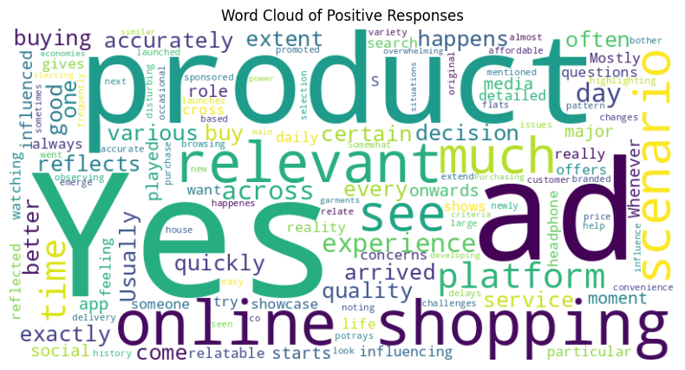

*Figure 10: positive word cloud*

Positive responses from the word cloud reveals that participants frequently associated targeted advertisements with being 'relevant’, 'quality’, ‘convenience’, ‘good', 'better', 'accurately' and 'useful' in the context of "online shopping". The prominent appearance of words like products, ads, and experience suggest that the ads were aligned with the participants interest or previous browsing behavior, there are more likely to view these ads favorably. The terms also indicate that the participants appreciated the convenience and efficiency provider by the targeted ads across different platforms. The inclusion of words like "yes" and "quickly" demonstrates a general affirmation of the role that personalized advertising place in developing their shopping experience, making it simpler to discover products of interest.

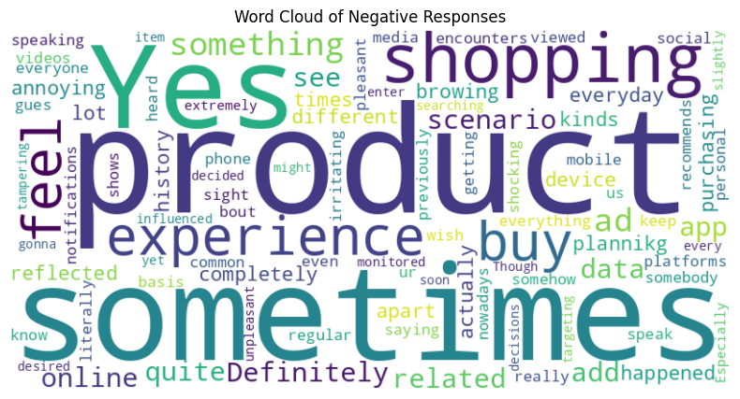

*Figure 11: negative word cloud*

However, the word cloud for the negative responses reflects a more critical perspective with words like "sometimes" depicts that some of the ads were received as occasionally relevant, there was also a notable level of frustration, as shown by words like annoying, irritating and unpleasant. The repetition of the words "shopping “in both positive and negative clouds indicates that while the shopping context is Central to the advertisement experience, it can have mixed reactions depending on the execution and the relevance of the ads. Terms like privacy, data, feel shows underlying concerns regarding data usage and the intrusiveness of targeted advertisements, with some participants expressing discomfort over being monitored or feeling overwhelmed by frequent exposure of advertisements.

*Table 3: Word frequencies*

|  |  |  |
| --- | --- | --- |
| Top Positive Words: | Word | Frequency |
|  | yes | 12 |
|  | ads | 8 |
|  | Online | 5 |
|  | shopping | 4 |
|  | product | 3 |
| Top Negative Words: | Word | Frequency |
|  | sometimes | 4 |
|  | something | 3 |
|  | not | 3 |
|  | product | 3 |
|  | shopping | 3 |

In conclusion, this research completely examined the key factors influencing the consumer behavior, emotional responses, and perceptions in the context of targeted advertisements. By addressing all the research questions, this study provides a valuable guidance for optimizing the digital advertising strategies for the marketers and better align them with consumer expectations and preferences.

**CHAPTER V DISCUSSIONS**

**5.1 Summary of the study**

This study aimed to explore the detailed relationship between targeted advertisements and consumer perceptions, focusing on various factors that influence the audience such as the context of recent purchases, demographics influences, and product categories etc. the research was designed around 4 key research scenarios with identical questions which guided the data collection and analysis. Using a structured questionnaire distributed via Qualtrics, responses were collected from 104 participants, offering insights into how consumers perceive and respond to targeted ads across different scenarios. The findings from the study contribute to the wider understanding of digital marketing strategies and consumer behavior particularly in the realm of targeted advertising.

**5.2 Theoretical Contribution**

The result of this study is highly aligned with the existing literature and several ways. For instance, the findings on the impact of purchase content on ad relevance and effectiveness correlate previous research that highlights the importance of timing and context in air placements (Ciuchita *et al.*, 2023; Uday Kiran and Arumugam, 2021). When one's person need is fulfilled, there is a consistent decline being observed in perceived relevance post purchase, their interest in related ads diminishes (Frick, Belo and Telang, 2023). However, this study also found that the effectiveness of ads remains significantly even after purchase, suggesting that post purchase engagement strategies can still be active. This phenomenon adds depth to existing theories, particularly in the context of brand loyalty and consumer retention strategies.

1. The analysis of brand loyalty and consumer dissonance offered new insights of how targeted advertisements can either mitigate or exacerbate feelings of regret or satisfaction. This finding supports the cognitive dissonance theory and expands on it by highlighting the role of AI in either enhancing or undermining experiences of customers, depending on the relevance of the ads (Chen *et al.*, 2019).
2. This study also explores the post-purchase ad effectiveness, finding that the effectiveness of ads remains significant even after purchase. This conveys that post-purchase engagement strategies can still be active, which challenges traditional views on ad timing and relevance.
3. This study also explores the demographic influences further conforms a critical role the factors such as age and gender play in shaping consumer responses, replicating the findings of (Meirezaldi, 2023) and (Truong, Nkhoma and Pansuwong, 2020).

**5.3 Discussion of Unexpected Outcomes**

One of the most unexpected outcomes of the study was the relatively stable effectiveness of ads in post purchase scenarios, despite a drop in passive relevance. This indicates that the consumers might still be receptive to advertisements if they pursue them as an offering value, even if the immediate relevance has vanished. Another unexpected finding was the higher level of dissonance observed among older age groups, particularly in electronic products. This might indicate a generational difference in how consumers process post purchase information and could suggest that older consumers are more prone to experiencing buyer's remorse.

**5.4 Practical Implications**

When it comes to practicality, the findings suggest that marketers should consider the context of recent purchases when designing targeted ad campaigns. The post purchase advertisements should focus on enhancing the consumer's experience, which possibly can be done by offering complementary products or services instead of same or similar products. Additionally, the study highlights the importance of the segmentation of demographics in ad targeting, particularly in crafting messages to different age groups. The observed difference between product categories in consumer responses also shows that marketers should adopt a category specific approach, with strategies tailored to the unique characteristics of each product type.

***Key points***

1. Marketers should mainly focus on strategies for post purchase engagement by delivering ads that match the consumer’s current needs instead of repetitive promotions of already purchased items to get an increased engagement and conversion rate.
2. It is crucial for advertisers to balance the personalization and privacy. The findings highlight that hyper-personalized ads should be delivered with transparent data usage policies to mitigate any privacy concerns from consumers. Preventing any potential negative reactions from the consumers, hence gaining their trust.
3. Study shows that different age groups respond to targeted ads in unique ways. Ad campaigns should be tailored according to the demographic differences in consumers, ultimately improving the effectiveness.
4. Implementing a product-category-specific strategy should be done for leading a more effective and resonant ad campaign across various consumer segments. It should align with the unique purchasing behaviour, emotional triggers and expectations associated with each product type.

**5.5 Research Limits and Future Research**

Even though this research provides valuable insights, there are few limitations to this study.

1. ***Sample size***: When it comes to the sample size, though they are sufficient for the scope of this research, this could be expanded in future studies to include a more diverse demographic, particularly in terms of geographic location and different cultural background.
2. ***Contextual focus***: Additionally, this study primarily focuses on digital advertisements in an online shopping context, in future research this could explore targeted ads in other contexts as well, such as social media or mobile applications.
3. ***Psychological Mechanisms***: Finally, another area where there could be future research involved is having a look deeper into the psychological mechanisms underlying consumer dissonance and brand loyalty in response to targeted ads.

**CHAPTER VI CONCLUSION**

This study manages to explore the complex interactions between the targeted advertisements and consumer behaviour, mainly focusing on the context of recent purchases, product categories, demographic factors and the integration of data analytics and AI. Through a quantitative survey distributed among 104 participants, this research provides insights into how consumers perceive and respond to targeted ads in different scenarios.

The findings of the study revealed that the context of recent purchases significantly influences the perceived relevance and effectiveness of the targeted advertisements, with post purchase scenarios showing a decline in relevance but maintaining effectiveness. This study also highlighted the role of consumer dissonance which shapes the brand loyalty, mainly in scenarios where no purchase was made. The difference across product categories that is particularly seen between fashion products and electronics products, underscores the need for category specific advertising strategies. Therefore, also the study confirmed the critical role of demographic factors such as age and gender, determining the effectiveness of targeted ads, with younger consumers showing a higher propensity of engagement. This study contributes to a broader understanding of digital marketing strategies, though it also raises ethical concerns particularly regarding the consumer privacy. Marketers are encouraged to adopt an appropriate approach that considers the unique characteristics of their target audience, the context of the purchases and the ethical implications of their strategies.

In conclusion this study highlights the important of context, personalization and ethical considerations in the design and implementation of targeted advertising campaigns. By building on the insights provided by this research, future studies can continue to refine our understanding of how to optimize digital marketing strategies which better aligns with consumer expectations and preferences.

# References

Ahmad, H., Teimouri Mokarram Tutor, S. and Kumeto, G. (2015) *Title: Programmatic Advertising Effect on Consumer Decision Making: Artificial Intelligence technologies in Advertising and Marketing and its Effect on Consumer Decision Making*.

Ai Le Yli-Kuivila (no date) *PROGRAMMATIC ADVERTISING AND CONSUMER ATTITUDES IN ONLINE RETAILING*.

Alaimo, C. and Kallinikos, J. (2018) *Objects, metrics and practices: An inquiry into the programmatic advertising ecosystem*. In: *IFIP Advances in Information and Communication Technology* [online]. 543, Springer New York LLC, pp. 110–123.

Andrew, D. (2019) Programmatic trading: the future of audience economics. *Communication Research and Practice* [online]. 5 (1), pp. 73–87.

Antunes, J. (2020) *THE EFFECTS OF PROGRAMMATIC ADVERTISING ON BRAND IMAGE-A SYSTEMATIC APPROACH FOR FASHION E-COMMERCE EVA HANSEN (33417) A Project carried out on the Master in Management Program, under the supervision of*.

Araujo, T., Copulsky, J.R., Hayes, J.L., Kim, S.J. and Srivastava, J. (2020) From Purchasing Exposure to Fostering Engagement: Brand–Consumer Experiences in the Emerging Computational Advertising Landscape. *Journal of Advertising* [online]. 49 (4), pp. 428–445.

Balocco, F. and Li, T. (no date) *Association for Information Systems Association for Information Systems LemonAds: Impression Quality in Programmatic Advertising LemonAds: Impression Quality in Programmatic Advertising* [online]. Available from: https://aisel.aisnet.org/icis2019.

Bolkvadze, E., Ekblad, R. and Borg, E. (no date) *Programmatic Advertising: Effective marketing strategy or invasion of privacy-A study of consumer attitudes towards Programmatic Advertising*.

Chen, G., Xie, P., Dong, J. and Wang, T. (2019) Understanding Programmatic Creative: The Role of AI. *Journal of Advertising* [online]. 48 (4), pp. 347–355.

Ciuchita, R., Gummerus, J.K., Holmlund, M. and Linhart, E.L. (2023) Programmatic advertising in online retailing: consumer perceptions and future avenues. *Journal of Service Management* [online]. 34 (2), pp. 231–255.

Cooper, D.A., Yalcin, T., Nistor, C., Macrini, M. and Pehlivan, E. (2023) Privacy considerations for online advertising: a stakeholder’s perspective to programmatic advertising. *Journal of Consumer Marketing* [online]. 40 (2), pp. 235–247.

Deng, S., Tan, C.W., Wang, W. and Pan, Y. (2019) Smart Generation System of Personalized Advertising Copy and Its Application to Advertising Practice and Research. *Journal of Advertising* [online]. 48 (4), pp. 356–365.

Diemert, E., Galland, P., Meynet, J. and Lefortier, D. (2017) *Attribution modeling increases efficiency of bidding in display advertising*. In: *2017 AdKDD and TargetAd - In conjunction with the 23rd ACM SIGKDD Conference on Knowledge Discovery and Data Mining, KDD 2017* [online]. Association for Computing Machinery, Inc.

Dwivedi, Y.K. *et al.* (2021) Setting the future of digital and social media marketing research: Perspectives and research propositions. *International Journal of Information Management* [online]. 59.

Frick, T.W., Belo, R. and Telang, R. (2023) Incentive Misalignments in Programmatic Advertising: Evidence from a Randomized Field Experiment. *Management Science* [online]. 69 (3), pp. 1665–1686.

Gonzalvez-Cabañas, J.C. and Mochón, F. (2016) Operating an Advertising Programmatic Buying Platform: A Case Study. *International Journal of Interactive Multimedia and Artificial Intelligence* [online]. 3 (6), p. 6.

HARALD J. VAN HEERDE, M.J.G.M.G.D. and J.-B.E.M.S. (no date) 38.

Högström, J. and Wallin, E. (no date) *Programmatic Advertising: A Quantitative Study of Consumer Attitudes Towards Highly Frequent Online Ads*.

Klee, C. (no date) *IN DEGREE PROJECT TECHNOLOGY AND MANAGEMENT, SECOND CYCLE, 30 CREDITS , STOCKHOLM SWEDEN 2021 AI in Marketing-Curse or Blessing? Impacts of Programmatic Advertising and Personalized Content on Society AI in Marketing-Curse or Blessing? Impacts of Programmatic Advertising and Personalized Content on Society*.

Kumawat, N. and Vajpai, M. (2022) *Programmatic optimization of ad pods for maximizing consumer engagement and revenue*.

Lee1, S. (no date) *A study on consent of the GDPR in advertising technology focusing on programmatic buying* [online]. Available from: https://ssrn.com/abstract=3616651.

Luiss, C.A., Carli, G. and Kallinikos, J. (2017) *Infrastructures of automation: Objects, metrics and practices in the programmatic advertising ecosystem* [online]. Available from: https://www.researchgate.net/publication/322754223.

Meirezaldi, O. (2023) PROGRAMMATIC ADVERTISING: Evolution, Efficacy, and Ethical Implications In The Digital Age. *Journal Publicuho* [online]. 6 (3), pp. 1069–1079.

Nalluri, V., Chang, J.-R., Chen, L.-S. and Liu, C.-C. (no date) *Identify critical factors for improving customer loyalty through programmatic advertising using feature selection* [online]. Available from: https://ssrn.com/abstract=4460043.

Niininen, O. (no date) *Contemporary Issues in Digital Marketing*.

Niklas Karlsson (2022) *‘2022 American Control Conference (ACC)’*. IEEE.

Nordman, N. (no date) *Effective Brand Communication for Sustainable Funds using Programmatic Marketing*.

Núnez-Barriopedro, E., Cuesta-Valiño, P. and Mansori-Amar, S. (2023) The role of perceived usefulness and annoyance on programmatic advertising: the moderating effect of Internet user privacy and cookies. *Corporate Communications* [online]. 28 (2), pp. 311–324.

Omodolapo Bakare, S. and Tolulope, O. (2021) *IJRISS) |Volume V, Issue VIII* *International Journal of Research and Innovation in Social Science* [online]. Available from: www.rsisinternational.org.

Palos-Sanchez, P., Saura, J.R. and Martin-Velicia, F. (2019) A study of the effects of programmatic advertising on users’ concerns about privacy overtime. *Journal of Business Research* [online]. 96, pp. 61–72.

Pan, J.-S., Li, J., Tsai, P.-W. and Jain, L.C. (20AD) *Smart Innovation, Systems and Technologies 156 Advances in Intelligent Information Hiding and Multimedia Signal Processing* [online]. 1. Available from: http://www.springer.com/series/8767.

Pawlata, H. and Cakir, G. (no date) *The Impact of the Transparency Consent Framework on current Programmatic Advertising Practices* [online]. Available from: https://orcid.org/0000-0001-9715-7167.

Prasad, A., Chokshi, S. and Khan, S. (2021) *Predictive programmatic re-targeting to improve website conversion rates*. In: *Journal of Physics: Conference Series* [online]. 1714 (1), IOP Publishing Ltd.

Rodgers, W. and Nguyen, T. (2022) Advertising Benefits from Ethical Artificial Intelligence Algorithmic Purchase Decision Pathways. *Journal of Business Ethics* [online]. 178 (4), pp. 1043–1061.

Samuel, A., White, G.R.T., Thomas, R. and Jones, P. (2021) Programmatic advertising: An exegesis of consumer concerns. *Computers in Human Behavior* [online]. 116.

Sarna, N., Kozminskiego, A.L. and Doligalski, T. (no date) *Programmatic advertising ecosystem as a multi-sided platform. An Evolutionary Perspective Nikodem Sarna Programmatic advertising ecosystem as a multi-sided platform. An Evolutionary Perspective* [online]. Available from: https://www.researchgate.net/publication/377782221.

Shehu, E., Abou Nabout, N. and Clement, M. (2021) The risk of programmatic advertising: Effects of website quality on advertising effectiveness. *International Journal of Research in Marketing* [online]. 38 (3), pp. 663–677.

Tiet, T. (2020) *THE PLANNING AND IMPLEMENTATION PROCESS OF PROGRAMMATIC ADVERTISING CAMPAIGNS IN EMERGING MARKETS Spring 2020 Title: The planning and implementation process of programmatic advertising campaigns in emerging markets Subject: Digital Marketing and Corporate Communication*.

Truong, V., Nkhoma, M. and Pansuwong, W. (2020) *Enhancing the effectiveness of mobile in-app programmatic advertising using publishers-controlled factors*. In: *ACM International Conference Proceeding Series* [online]. Association for Computing Machinery, pp. 146–150.

Uday Kiran, K. and Arumugam, T. (2021) *Role of programmatic advertising on effective digital promotion strategy: A conceptual framework*. In: *Journal of Physics: Conference Series* [online]. 1716 (1), IOP Publishing Ltd.

Wang, P., Xiong, G. and Yang, J. (2019) Serial position effects on native advertising effectiveness: Differential results across publisher and advertiser metrics. *Journal of Marketing* [online]. 83 (2), pp. 82–97.

Wang, Y.Y., Nalluri, V. and Chen, L.S. (2023) Using a Text Mining Approach to Identify Important Factors Influencing the Performance of Programmatic Advertising †. *Engineering Proceedings* [online]. 38 (1).

Watts Mack (2016) Programmatic Advertising: Shaping Consumer Behavior or Invading Consumer Privacy?

Weinlich, P. and Semerádová, T. (2017) *PREPRINT Effectiveness of Automatic Retargeting in Programmatic Advertising* [online]. XX. Available from: https://ssrn.com/abstract=4113049.

White, G.R.T. and Samuel, A. (2019) Programmatic Advertising: Forewarning and avoiding hype-cycle failure. *Technological Forecasting and Social Change* [online]. 144, pp. 157–168.

**APPENDIX**

**APPENDIX 1: Participant information sheet, Consent form and Questionnaire**

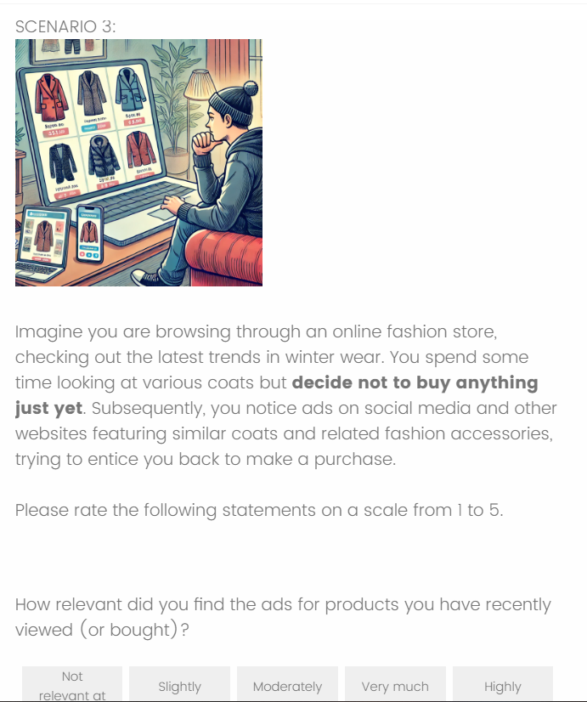

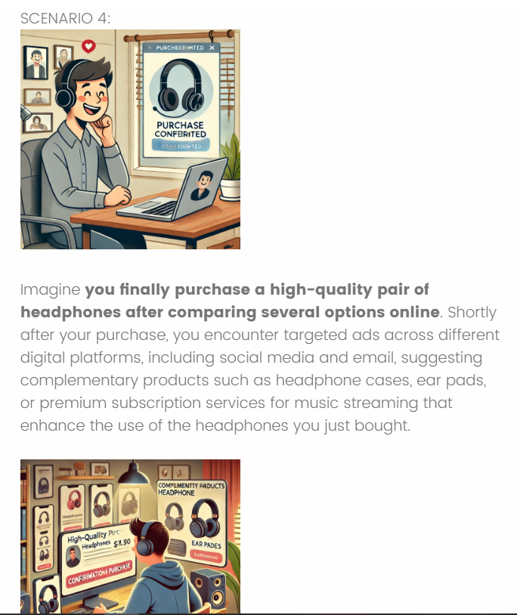

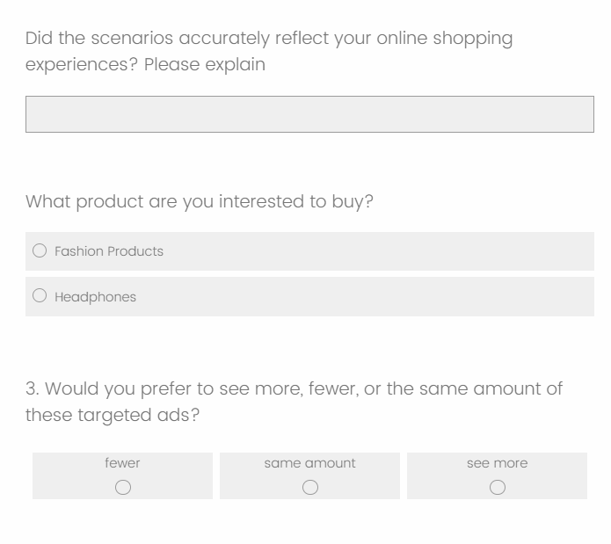

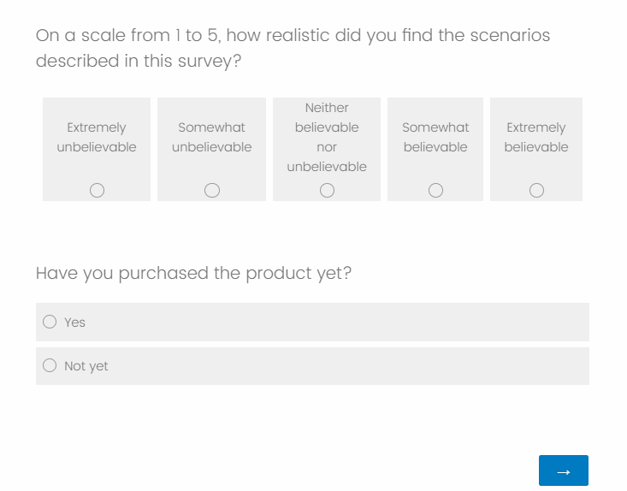

**APPENDIX 2: Relevant dataset**

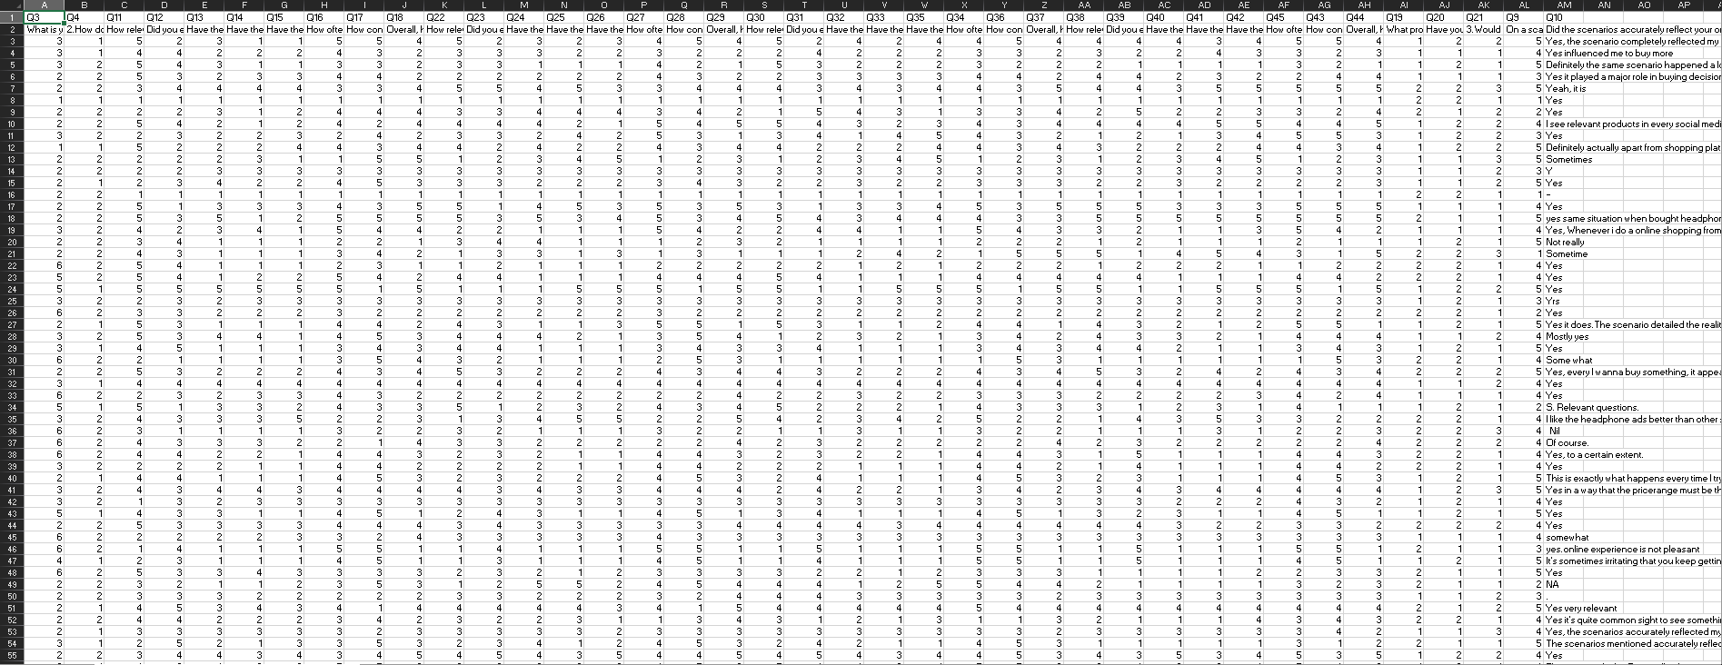

**APPENDIX 3: Ethical Approval Document**

**APPENDIX 4: PYTHON CODE**

**File link:** [**dissertation .ipynb**](https://uob-my.sharepoint.com/:u:/g/personal/yt23325_bristol_ac_uk/EUMV69Yj8hpDqFIrV50u5M0Big0WYMblidqyTjUZ7DYS3Q?e=KiBBEY)

**Google colab File link:** [**https://colab.research.google.com/drive/1PMNBlj4NTCAvOt-y_42uGk60OX9Vpua5?usp=sharing**](https://colab.research.google.com/drive/1PMNBlj4NTCAvOt-y_42uGk60OX9Vpua5?usp=sharing)

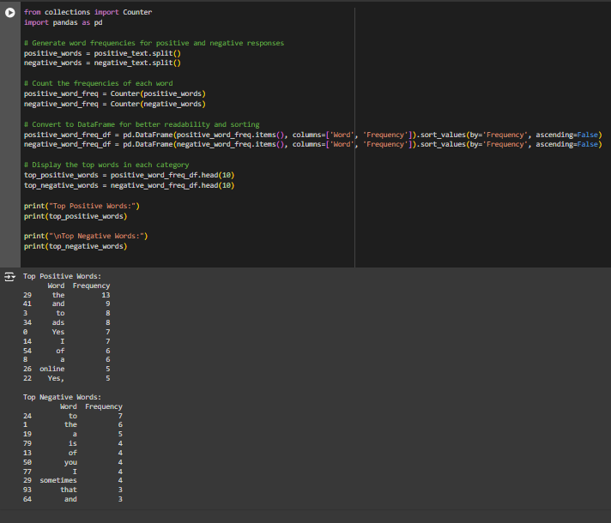

**APPENDIX 5: SUPERVISOR AGREEMENT FORM**

